A. Parcel/Account Query

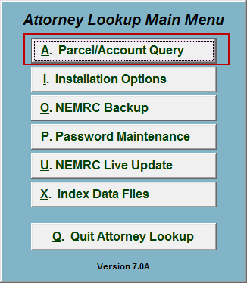
Click on “A. Parcel/Account Query” from the Main Menu and the following window will appear:

Parcel/Account Query

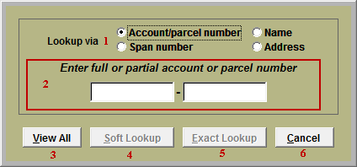
- Lookup via: Select the method to be used to look up Parcel/Account.

- Enter full or partial…: This area will change based on the choice in item 1. Enter the information to look up.

- View All: Click this button to view all Parcels/ Accounts in a sort-able list. Gathering the data will take a few moments.

- Soft Lookup: Click this button to look for any Parcel/Accounts with the information entered in item 2. Gathering the data will take a few moments.

- Exact Lookup: Click this button to look for a Parcel/Account with the exact information entered in item 2. Gathering the data will take a few moments.

If no Parcel/Account matches the information entered in item 2, then you will be notified that no records were found.

If multiple Parcels/Accounts match the search, then the following Lookup window will appear. If only a single Parcel/Account matches the search, then the following Output window will appear.

Lookup Window
The following window will appear if more then one Parcel/Account matched the query.

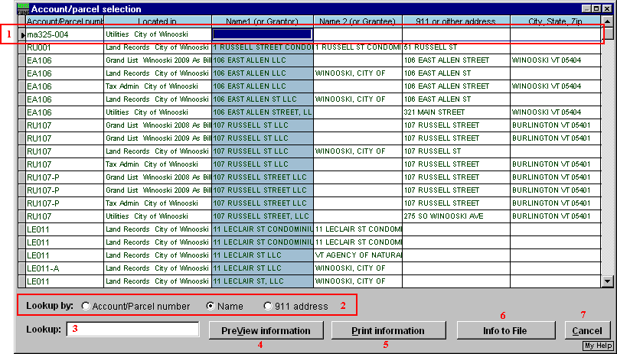
- The arrow on the left represents the field that is selected.

- Lookup by: Select what the list is sorted by. This is also the column searched when using item 3. This is the blue-gray column.

- Lookup: Enter partial information based on item 2, and the list will automatically scroll to the closest matching field.

- PreView information: Click this button to preview the Parcel/Account’s information. Refer to GENERAL PREVIEW for more information.

- Print information: Click this button to print the Parcel/Account’s information. Refer to GENERAL PRINTING for more information.

- Info to File: Click this button to save the Parcel/Account’s information to a file. Refer to GENERAL FILE for more information.

- Cancel: Click “Cancel” to cancel and return to the previous screen.

Output Window
The following window will appear if there was only one Parcel/Account that matched the query.

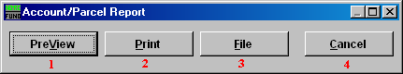
- PreView: Click this button to preview the Parcel/Account’s information. Refer to GENERAL PREVIEW for more information.

- Print: Click this button to print the Parcel/Account’s information. Refer to GENERAL PRINTING for more information.

- File: Click this button to save the Parcel/Account’s information to a file. Refer to GENERAL FILE for more information.

- Cancel: Click “Cancel” to cancel and return to the previous screen.

